

__________________________________________________________

**RHODES UNIVERSITY SUSTAINABLE LAND MANAGEMENT FOR RURAL RESILIENCE PROJECT (RU-SLMRR), GEF5**

**QUARTERLY PROGRESS REPORT**

______________________________________________________________

**Report compiled by**: Dugal Harris

**Organization**:

**Quarter and year**: 032018

**Reporting outputs**: 3.1b

**Date of report:** 21092018

__________________________________________________________________________________

# INSTRUCTIONS

# Please refer to Sections A-E below and include the necessary information and attachments to document your progress toward one or more outputs of the GEF5 SLMRR Project (use the examples provided to guide you).

# Please submit your completed progress report on or before the 12th day of the final month of a particular quarter. This is according to reporting regulations set by Department of Environmental Affairs for the GEF5 SLM Project.

# Please submit your report to: Rebecca Powell (rebeccajoub@gmail.com) and cc James Gambiza (j.gambiza@ru.ac.za).

# SECTION A: OUTPUTS PROGRESS & CHALLENGES (Please complete columns A-F in the table below)

**\***Progress toward achieving planned activities indicated in column C.

**\*\*** Challenges to achieving progress on activities, as identified in columns C and D

| AOutput code | BYR1 goals (deliverables) | CPlanned activities for reporting quarter | DProgress*1 = completed, no concerns; 0.5 = partial progress, some concerns; 0 = no progress, major concerns | EChallenges** | FAddressing challenges |
| --- | --- | --- | --- | --- | --- |
| 3.1b | Report on the development of a new carbon methodology for Spekboomveld rehabilitation projects and applicability to these kinds of projects | 1) Apply differential correction to field DGPS data acquired during Q2&3.  2) Process Q2&3 field allometric data to produce woody carbon stock (CS) estimates.  3) Acquire satellite (WorldView-3) image of study area.  4) Conduct field trip to acquire GCP's for orthorectification.  5) Orthorectify and radiometrically calibrate satellite image.  6) Basic correlation analysis on data acquired to date. | 1) 12) 0.53) 14) 15) 0.756) 1 | 2) Allometric models do not exist for all species. Q3 data is not yet available.5) The image as been orthorectified and radiometrically calibrated with ATCOR-3. An experiment to radiometrically calibrate the image using a reference Sentinel-2 image is still outstanding. | 2) Species without models are in the process of being grouped into guilds with known species. Q3 data will be included when it is available.5) The Sentinel-2 radiometric calibration will be performed in Q4 and compared to results from the existing ATCOR-3 corrected image. |

# SECTION B: IDENTIFIED RISKS AND SOLUTIONS

# Describe the identified risks to the project outputs

# *Allometric models are not available for some species.*

# *There are plans for additional carbon stock field sampling in Q4. This data is required to complete the carbon stock mapping work.*

# Describe possible solutions to identified risks

# *These species are being grouped into guilds with similar known species. A new allometric model for S. Longispina can be derived from existing data.*

# *If all carbon stock data is not available by end October, it may be necessary to extend the carbon stock mapping working into 2019.*

# SECTION C: SUMMARY OF LESSONS LEARNT DURING THE REPORTING QUARTER

# *Using DGPS acquired ground control points (GCP’s), it was possible to othorectify a WorldView-3 satellite image of the study area to a horizontal RMSE of ± 0.5m.*

# *A preliminary regression analysis for predicting (woody and litter) above ground biomass (AGB) C from WorldView-3 image features produced useful accuracies (R2=0.85 and RMSE=7.22 t/ha). These results represent a modest improvement on the previous woody C Q2 results obtained with NGI aerial imagery (R2=0.78 and RMSE=8.89 t/ha).*

# SECTION D: BUDGET TRACKING

# Please note that you will be required to submit a financial report at the end of 2017 (Before December) detailing your expenditure for the year. This requires that you keep a record of all invoices and receipts relating to project expenditure. The format for the report will be sent closer to the time.

**SECTION E: APPENDICES**

**APPENDIX 1 (activities 1 - 5):**

Figure *1 shows a colour-infrared rendering of an orthorectified, atmospherically corrected and pan-sharpened (October 2017) WorldView-3 satellite image covering the GEF study areas. The 30cm resolution panchromatic band was orthorectified using a set of 28 field acquired GCPs (displayed on the map). The eight 1.2m resolution multi-spectral bands were subsequently orthorectified by automatic matching to the corrected panchromatic band. Orthorectified bands were then corrected to surface reflectance with ATCOR-3 and pan-sharpened.*

*The “pristine, “moderate” and “severe” degradation classes were used for stratifying the sampling plots. AGB C estimates were generated for each of the plots using field measurements acquired by Cosman Bolus and allometric models built by Marius van der Vyver. The 61 plots processed to date, coloured according to their above ground (woody + litter) C estimates, are displayed on the map.*

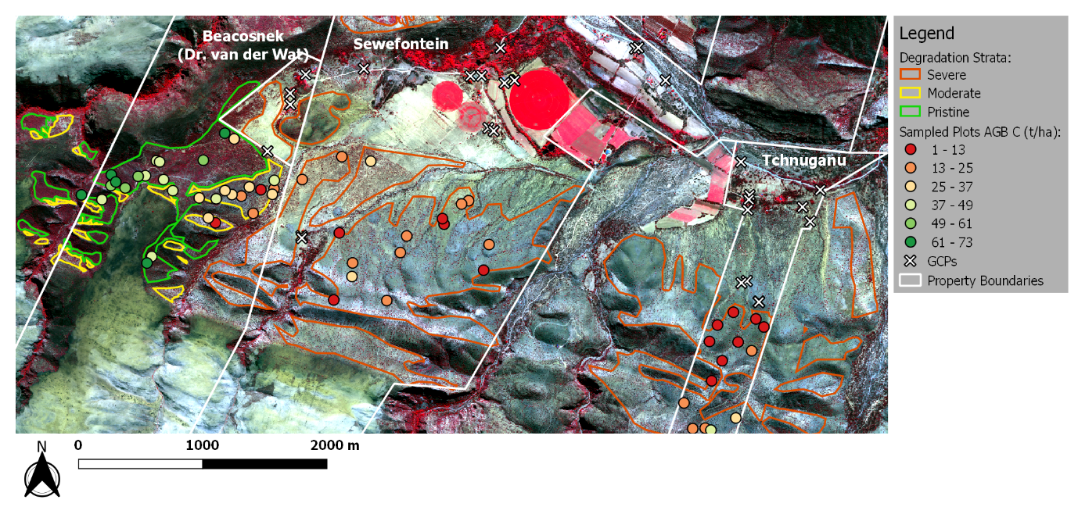

Figure 1 Map of GEF study area with AGB C for sampled plots

**APPENDIX 2 (activity 6):**

*A basic multivariate regression analysis was conducted to investigate the feasibility of modelling AGB C using image features. Data from the available 61 sampling plots were used for this investigation. Common spectral, textural and vegetation index measures were extracted from a calibrated WorldView-3 image for each sampling plot. A feature library incorporating non-linear functions of these measures was subsequently constructed. Using an F-statistic importance measure, the best individual feature was identified as the normalised red channel ().* Figure *2 shows a reasonably strong correlation between this feature and the AGB C estimates. The best combination of features for a multivariate linear model was determined using the LASSO feature selection method. Details of the four chosen features are given in Table 1.*

*A multivariate linear model was constructed with the LASSO selected features and validated using leave-one-out cross validation. The model produced an**R2 of 0.85 and a root mean square error (RMSE) of* *7.22 t/ha with 5 - 95% confidence interval of 0.81 - 13.62 t/ha. Further sampling plot measurements are required to establish better representivity of the CS variation, and to reduce the RMSE confidence interval. Further sampling plots will also allow the investigation of more sophisticated regression models and image features, including features derived from all 8 WorldView-3 bands.*

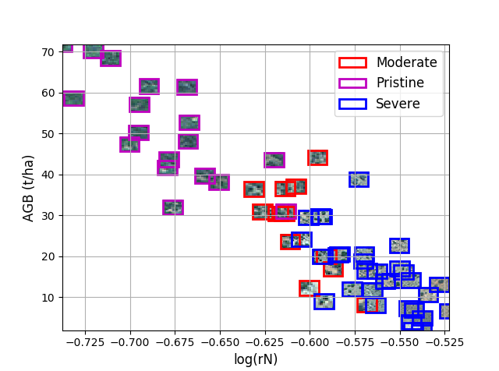

Figure 2 AGB C and normalised red scatter plot

|  |  |  |
| --- | --- | --- |
| **Feature Description** | **Feature Equation** | **Coefficient** |
| Normalised red |  | -229.34 |
| NDVI |  | 29.26 |
| NDVI standard deviation |  | -16.15 |
| Infrared ratio |  | -14.70 |

Table 1 Details of LASSO selected features (R, G, B and NIR refer to the red, green, blue and near-infrared channels respectively)

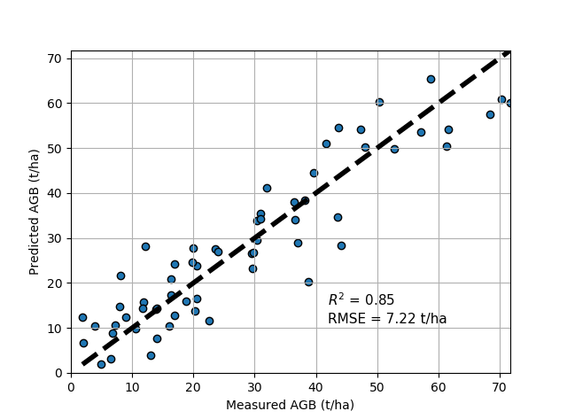

Figure 3 Measured and predicted AGB C scatter plot

*Field litter estimates are made in four 0.5m* x *0.5m quadrats which represents a small area compared to the 10m* x *10m or 20m* x *20m plot for woody C. Due to concerns around the representivity and variability of litter C estimates (and the possible effect these may be having on model accuracy), the regression analysis was repeated, but on the woody C estimates only (i.e. excluding litter). A multivariate linear model was again constructed with the LASSO selected features and validated using leave-one-out cross validation. Results are shown in* Figure *4.*

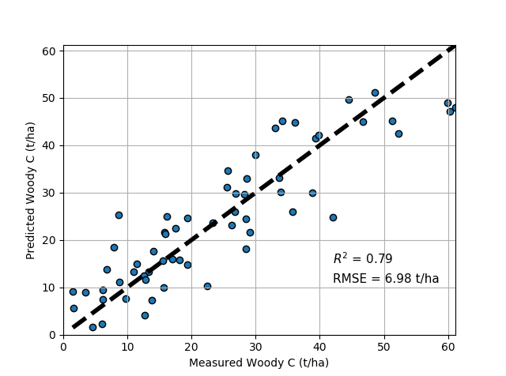

Figure 4 Measured and predicted Woody C scatter plot